Indian Institute Of Technology Kanpur

AE 351A

Experiments in Aerospace Engineering 2020-21

Semester II

**Experiment No. 8**

**Measurement of Pressure Distribution over a Circular Cylinder in the Wind Tunnel**

**Submitted By:**

Ankit Lakhiwal

180102

[(ankitl@iitk.ac.in)](mailto:ankitl@iitk.ac.in" \t "/home/logan/Documents\\x/_blank)

Department of Aerospace Engineering

March 19, 2021

1. **Objective**

* Measure and Plot the Cp distribution over the cylinder and compare with theoretical Values.
* Calculate Cd distribution over the cylinder.
* Plot the variation in Cd Vs Re

1. **Apparatus**

* Low speed wind tunnel
* Model
* Electronically Scanned Pressure sensor
* Multiplexer Unit
* Digital Interface and Line Driver (DILD) unit for ESP Scanners
* Data Acquisition Board
* Pressure Data Acquisition and Analysis Software
* Pitot Static tube

1. **Procedure**
2. Measure the cylinder diameter and note down the ambient temperature and pressure which will be used for calculating Reynolds number.
3. Mount the pitot static in the test section to measure the flow velocity.
4. Connect the pitot static tube and static measurement port of the cylinder to the digital manometer.
5. Run the data acquisition VI and take the no wind readings.
6. Increase the speed to the desired value, and after the flow stabilizes, save the wind data.
7. Repeat the same for another set of speed.
8. Run the data analysis VI to write the data to a spreadsheet file.

**The specifications of the low speed wind tunnel are**

|  |  |  |
| --- | --- | --- |
| S. No. | Property | Measurement |
| 1 | Type | Open – Return Suction Type |
| 2 | No. Of Screenings in the settling chamber | 6 |
| 3 | Contraction ratio | 16:1 |
| 4 | Test section | dimensions 0.6 m X 0.6 m X 3 m 5 |
| 5 | Velocity | Max. ~ 25 m/s |
| 6 | Motor | 20 Hp AC |

1. **Calculations**

The flow pattern and the drag on a cylinder are functions of the Reynolds number $R_{e} = \frac{UD}{ν}$ based on the cylinder diameter D and the undisturbed free-stream velocity U.

$$C_{p} = \frac{P−P∞}{\frac{1}{2}ρU^{2}}$$

$$C_{d} = −\frac{1}{2}\int_{0}^{2π}{C_{P}\cos{θ}}dθ$$

1. **Results**
2. Measured Pressure distribution on circular cylinder compared with theoretical distribution

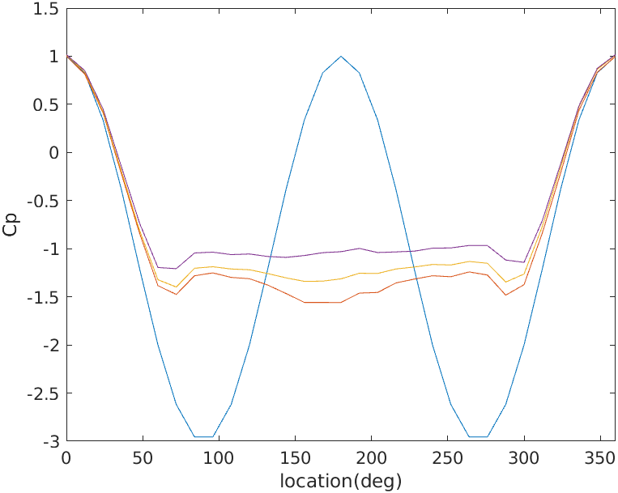

1. **Error Analysis**

The error in measurement can be classified as:-

1. Systematic Error: These arise due to improper calibration of instruments or some other unknown reasons. They can be eliminated by proper calibration of instruments orrectifying the fault. This defines the accuracy of the measurement made. The lesser the bias, the higher the accuracy. These are biased in nature.
2. Random Error: These occur due to the natural disturbances that occur during the measurement process. These cannot be eliminated. This defines the precision of the measurement made. These are statistical in nature.
3. **Appendix**

